**Level 1: PC Tower Case**

**Outline**

Learn about the internals of a standard PC case by examining physical samples and selecting and labeling images found on-line. Gain deeper knowledge by researching and reporting on specific components.

**Questions**

1. Find one (or more) images that clearly show the internals of a PC Tower Case.   
   (i.e. Google images using keywords “PC Case Internals”)
2. Clearly label the following components (using arrows) on your image of the PC case internals:
   * Motherboard
   * Power Supply
   * Hard Disk Drive
   * Optical Disk Drive (e.g.DVD)
   * USB Expansion Ports
   * Monitor Port
   * Audio Ports
   * Ethernet Port
   * Cooling Fan

**On Github Repository separate PowerPoint**

1. Research more in-depth about “Motherboards”. Make notes on the following:

What different versions are currently available (speed and capacity)

* **Motherboards offer more R.A.M slots (up to 8)**
* **Bigger motherboards**
* **Have more slots**

How the component has changed since the 1980’s

* **Ram slots back then only were offered in only MB now they have GB**
* **Have a separate slot for a graphics card for better graphics**

1. Research more in-depth about “Hard Disk Drives”. Make notes on the following:

What different versions are currently available (speed and capacity)

* + **Up to 8 Terabytes in hard drives**

How the component has changed since the 1980’s

* + **Back then hard drives were only available in Gb’s**

**Level 2: PC Motherboard**

**Outline**

Learn about the structure of a standard PC motherboard by examining physical samples and selecting and labeling images found on-line. Gain deeper knowledge by researching and reporting on specific components.

**Questions**

1. Find one (or more) images that clearly show the layout of a PC Motherboard.   
   (i.e. Google images using keywords “PC Motherboard”)
2. Clearly label the following components (using arrows) on your image of the PC motherboard:
   * CPU (and fan)
   * RAM Memory
   * Disk Drive Interface (IDE or SATA)
   * GPU Graphics Processor (either on-board or Graphics Card)
   * Sound Processor (either on-board or Sound Card)
   * Wi-Fi / Ethernet Network Interface (either on-board or Graphics Card)

**On github repository**

1. Research more in-depth about “CPU Processor Chip”. Make notes on the following:

What different versions are currently available (speed and capacity)

* + **Faster**
  + **Can address more memory**
  + **64-bit**

How the component has changed since the 1980’s

* **8-bit CPUs**
* **Slow**
* **Low amount of slots for Graphics cards/PCI’s/RAM slots**

1. Research more in-depth about “RAM Memory”. Make notes on the following:
   * What different versions are currently available (speed and capacity)
   * **DDR3 and DDR4 RAM sticks are much faster**
   * **Can have up to 128GB of R.A.M**
   * How the component has changed since the 1980’s
   * **R.A.M was in MB**
   * **Low amount of R.A.M**

**Level 3: Peripheral Devices**

**Outline**

Learn about how peripheral devices are connected to the back side of a typical PC tower case. Examine physical samples, select and labeling images found on-line and gain deeper knowledge by researching and reporting on specific components.

**Questions**

1. Find one (or more) images that clearly show the layout of the back of a typical PC tower case.   
   (i.e. Google images using keywords “Back Of PC Tower”)
2. Clearly label the following components (using arrows) on your image of the back of a typical PC tower case:
   1. Power cord and power switch

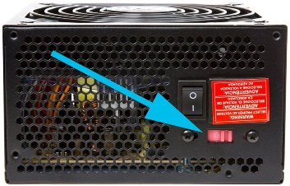

* 1. Monitor Interface (VGA or DVI or HDMI)

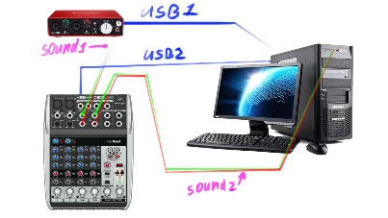

* 1. Mouse Interface (USB or PS/2)  
     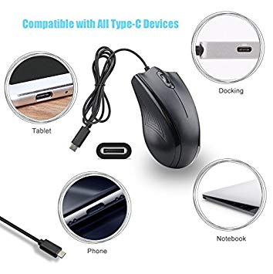
  2. Keyboard Interface (USB or PS/2)

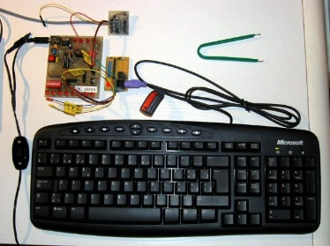

* 1. USB Ports

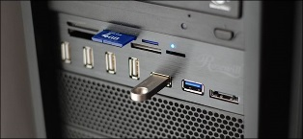

* 1. Audio Inputs / Outputs

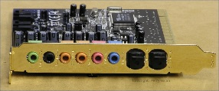

* 1. Ethernet Interface

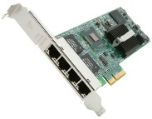

1. Research more in-depth about “Monitor Technology”. Make notes on the following:
   1. What different versions are currently available (e.g. VGA / DVI, Flat Panel Technology)

**Panel technologies. The overwhelming majority of computer monitors, laptop screens and tablets are based on TFT-LCD**

* 1. How the component has changed since the 1980’s (e.g. Display Resolution, Technology)

**Electrically operated display devices have developed from electromechanical systems for display of text, up to all-electronic devices capable of full-motion 3D color graphic displays. One of the earliest electronic displays is the cathode ray tube (CRT), which was first demonstrated in 1897 and made commercial in 1922.**

1. Research more in-depth about “External Portable Storage”. Make notes on the following:
   1. Floppy Disks

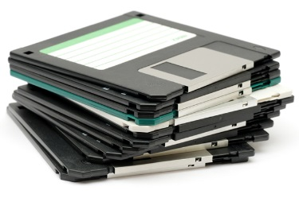

* 1. CD-ROM / DVD / Recordable CD/DVD

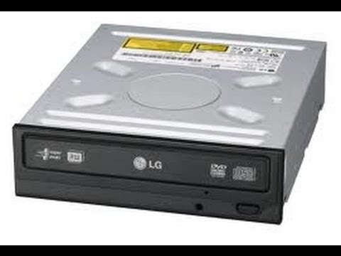

* 1. USB Memory Drives

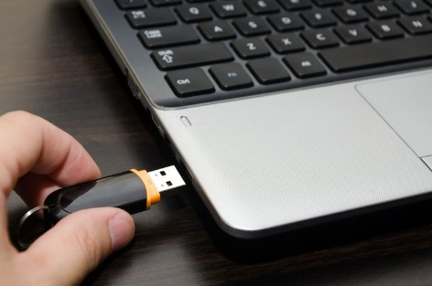

* 1. Compact Flash Memory

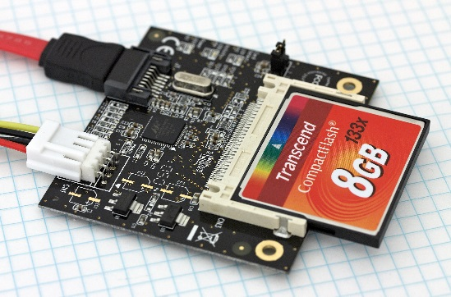

* 1. Cloud Based Storage  
     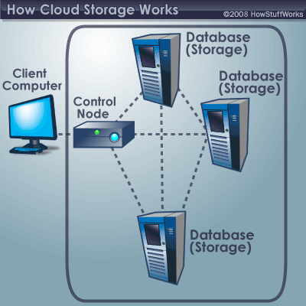

**Level 4: PC Component Presentation**

**Outline**

Explore the development and features of a specific PC hardware component through deeper research and investigation. Work in partners to create a short presentation. Deliver the presentation to the class.

Each group will research a unique PC hardware component . Your specific topic will be assigned from the list provided below.

**Presentation Structure**

1. Explain what the PC component does and how it fits together with other components to make up a fully functioning PC.  
   **This component provides exceptional graphics for the PC making gaming much smoother and faster.**
2. Explain how the PC component works. Provide a diagram (image) showing the main parts of the component.
3. Research the current state of the art of the component in terms speed, capacity (size), and other related factors.
4. Research on-line suppliers that sell the PC Component. List the specifications for the available products and the cost (price).
5. Research how the PC component has changed and evolved since the early days of PCs in the 1980’s. Cover each of the following topics separately:
   1. Component Speed
   2. Component Size / Capacity
   3. Two other specifications specific to the PC component (ask Mr. Nestor)

**PC Component Topics**

|  |  |  |
| --- | --- | --- |
| **Topic** | **Partner 1** | **Partner 2** |
| CPU Microprocessor Chip |  |  |
| Motherboard Layout |  |  |
| Computer Graphics | Arjunvir Sidhu | Sahajdeep Kang |
| Sound & Audio |  |  |
| Hard Disk Drives |  |  |
| Removable Disk Storage |  |  |
| Network / Internet Connectivity |  |  |
| Mouse / Pointing Devices |  |  |
| Monitor & Display Technology |  |  |
| Printers & Output Technology |  |  |